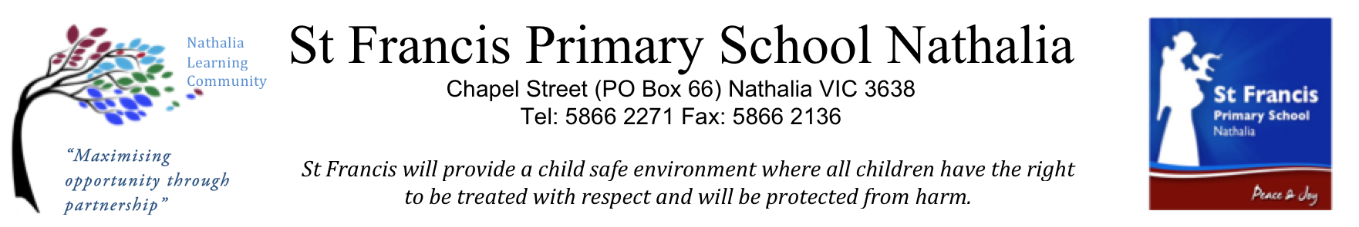

Volunteer Induction Completion
Volunteer
I confirm that I have completed a first-week induction process with my principal/supervisor/other delegated staff member.
I acknowledge that I have read and understood the following:
Please tick to indicate your acknowledgement and understanding
Visit www.sfnathalia.catholic.edu.au to view the on-line ‘Volunteers Powerpoint.
 | Code of Conduct |  |  | Child-Safe Policies
 | Occupational Health and Safety |  |  | Cyber Safety
 | Anti-Bullying |  |  | Watched the on-line ‘Volunteers’ Powerpoint
Volunteer’s name:
Signature:
Date signed:

Principal/Supervisor
I confirm that induction has been provided and certify that the above-mentioned volunteer has completed first-week induction procedures and received all training as identified during the induction process.
Principal/Supervisor’s name:
Signature:
Date signed:

Copy of this checklist provided to new volunteer on (date):

