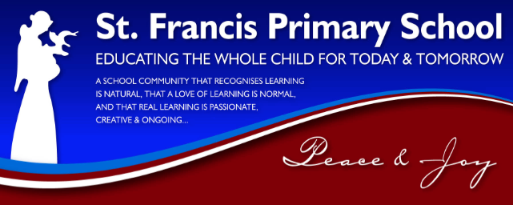
Occupational Health & Safety Policy

St Francis Catholic School, in the Franciscan tradition, educates the whole child for today and tomorrow.
We believe in:
PEACE & JOY
Embracing our Catholic Identity through the fostering of Christian values.
Nurturing a welcoming, compassionate and caring environment that draws together children, parents, teachers and community.
INTEGRITY
Developing a sense of responsibility and self-esteem in each individual.
JUSTICE
Building and nurturing a stimulating learning community where all are supported in reaching their full potential.
CREATION
Respecting and taking action to sustain our natural environment.

Commitment to child safety
All students enrolled, and any child visiting, have a right to feel safe and be safe all of the time. The wellbeing of children in our care will always be our first priority and we have zero tolerance for child abuse. At St Francis we strive to maintain a child safe and child friendly environment where children feel safe and are free to enjoy life to the full without any concern for their safety. We are committed to continually reviewing our Child Safe policies and practices to ensure that every effort is made for ongoing improvement of our Child Safe environment.
We at St Francis recognise that some groups of children are particularly vulnerable are we are committed to promoting the cultural safety of Aboriginal/linguistically diverse children and also promoting the safety of children with a disability.
St Francis School Nathalia is committed to providing a healthy and safe working environment for all our staff, students and visitors. This is not only a legal requirement: it is an integral part of the way we deliver excellent educational outcomes.
In accordance with the Occupational Health and Safety Act 2004, the school’s leadership team undertakes to meet its responsibility to provide a healthy and safe workplace. Where necessary, procedures and practices will be developed to ensure that all tasks are carried out safely and without risk to health. The leadership team will consult with staff to identify and resolve health and safety issues. It will ensure that the ways we deal with health and safety issues are regularly reviewed and improved if necessary.
The principal, assistant principal, and OH&S team are accountable for implementing St Francis School Nathalia’s health and safety procedures and practices within the areas of their responsibility.
In accordance with the OHS Act, St Francis School Nathalia expects all staff members to take care for their own health and safety, and the health and safety of others. Staff members are expected to report health and safety issues and to co-operate with the actions taken by the school to protect their health and safety.
The principal is the senior leader responsible for St Francis School Nathalia’s OHS program.
This policy will be reviewed annually and will guide all OH & S policies and procedures as listed on the document control list.

