Description of Volunteer Role – St Francis Nathalia 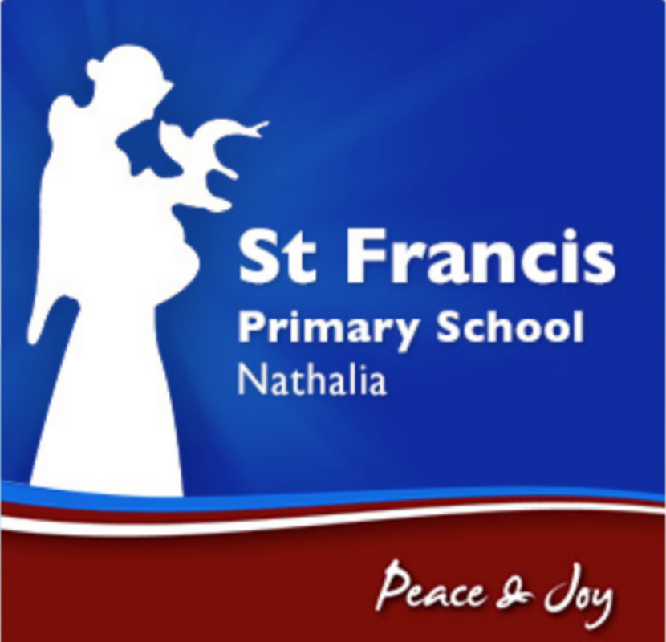
Statement of Duties

Duties | - Assisting teachers with school-based tasks, including:  - display set-up  - resource preparation  - book covering.  - Supporting literacy and numeracy activities, including:  - group reading  - mathematics activities.  - Assisting in a wide range of day-to-day school activities, such as:  - photocopying  - processing library books  - general classroom activities  - editing school magazine  - laminating.  - Assisting in school lunches and catering:  - general food handling  - preparing sandwiches  - serving at the counter  - wiping down counters  - washing and putting away utensils  - general cleaning duties  - Assisting school teaching staff in coordinating an excursions/camps by:  - supervising students as required  - assisting with post-meal mess clean-up  - taking students to/from toilets, drinking fountains etc.  - praising appropriate behaviour and encouraging modification of inappropriate behaviour  - modelling acceptable behaviour and language.  - Assisting the physical education teacher by:  - setting up and packing away sports equipment  - encouraging students to participate in activities that promote fitness and development of sporting ability.  - Other duties as directed.

Selection Criteria
Commitment to Catholic education | - An understanding of and respect for the school values of St Francis
Child safety | The volunteer must:  - have experience of working with children  - demonstrate an understanding of appropriate behaviours when engaging with children  - be a suitable person to engage in child-connected work  - hold or be willing to acquire a Working with Children Check card and must be willing to undergo a National Police Record Check.

